COMENIUS UNIVERSITY IN BRATISLAVA, FACULTY OF MEDICINE
INSTITUTE OF MEDICAL PHYSICS, BIOPHYSICS, INFORMATICS AND TELEMEDICINE

RADIOTHERAPY

Semestral work from biophysics (medical biophysics)

Academic year: 2013/2014 Maria Fessatidou
RNDr, Eva Kralova Group 4

1
Contents:
Page

Abstract 3
Introduction 3
Radiation in Medicine 4
Radiotherapy: What is it? 5
Types of Radiotherapy:
    - External Radiotherapy 6
    - Internal Radiotherapy 7
Side Effects of Radiotherapy 8
Conclusion 8
Literature 9

2
Abstract

Radiotherapy is a treatment that involves the use of high-energy radiation. It is commonly used to cure or control cancer. Radiation therapy uses X-rays to destroy or injure cancer cells so they cannot multiply.

The aim of radiotherapy is to damage as many of the cancer cells as possible while harming only a few of the normal, healthy ones.

Almost half of all people with cancer have radiotherapy as part of their treatment plan.
It may be the only treatment used, or used in combination with surgery and/or chemotherapy. It can also be used to treat benign (non-cancerous) tumors, relieve pain and treat other conditions such as thyroid disease and some blood disorders.

Key Words:
Radiation, high-energy radiation, X-rays, cancer cells, tumors, chemotherapy

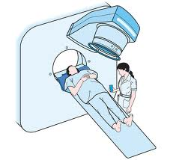

Introduction

Wilhem Rontgen, a German physics professor, discovered X-rays in 1896. Emil Grubbe, a student doctor in Chicago, became the first person to use radiation to treat cancer. And three years later, two Swedish doctors used radiotherapy to cure several cases of head and neck cancer. In 1901, Rontgen was awarded the Nobel Prize for his discovery.

Early radiotherapy consisted of a single massive dose of radiation, typically lasting an hour. Side effects were severe. In 1914, an Austrian doctor controversially suggested that radiotherapy might work better if it was given in many smaller doses (fractionated radiotherapy).

Over the next thirty years, engineers built even more powerful X-ray sources. Since then, a number of technological developments have allowed radiologists to target the X-ray beam more accurately and avoid damaging normal tissue, further improving radiotherapy as a cancer treatment.
3
Radiation in Medicine

The application of radioactive substances in the diagnosis and treatment of a disease, can best describe the relation between radiation and medicine. Radiation is energy that comes from a source and travels through space and is able to penetrate various materials. Light, radio, and microwaves are types of radiation that are called non-ionizing.

Most people at some time in their lives have an X-ray examination to help the physician diagnose disease or damage in the body. A much less common diagnostic procedure involves the administration of radionuclides to patients so that detectors outside the body can be used to observe how organs are functioning. Physicians use either of these procedures if they cannot make a diagnosis without them. Radiation doses are generally low, although they can be appreciable in certain procedures.
Much higher doses are required to treat malignant diseases or malfunctioning organs sometimes in combination with other forms of treatment. A beam of radiation may be used to irradiate the affected part of the body or a fairly high activity of a radionuclide may be administered to the patient.
The use of X-rays for examining patients is called diagnostic radiology and the use of pharmaceuticals labeled with radionuclides for diagnosis or therapy is called nuclear medicine. When radiation beams are used to treat patients, the procedure is called radiotherapy.

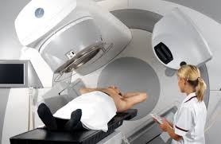

4
Radiotherapy
Radiation therapy uses controlled high-energy rays to treat tumors and other diseases of the body. The beams of radiation in radiotherapy are more powerful than ordinary X-rays. They aim to destroy cancer cells with as little damage as possible to normal cells. Radiation works by damaging the DNA inside the cells making them unable to divide and reproduce. Abnormal cancer cells are more sensitive to radiation because they divide more quickly than normal cells. Over time, the abnormal cells die and the tumor shrinks. Normal cells can also be damaged by radiation, but they can repair themselves more effectively.
Radiation is often given with the intent of destroying the tumor and curing the disease (curative treatment). However, the effects are not immediate; the treatment benefit occurs over time. Typically, more aggressive tumors, whose cells divide rapidly, respond more quickly to radiation. Radiation therapy is painless and will not make you radioactive.
Nevertheless, not all disease or cancer can be cured with radiation. Sometimes radiation is used to relieve symptoms, such as pain or seizures (palliative treatment). Sometimes it is used to prevent tumors from developing or spreading (prophylactic treatment). Radiation may be used alone or in combination with other treatments such as surgery, chemotherapy or immunotherapy. If used before surgery, radiation will shrink the tumor to make it easier to remove. If used after surgery, radiation will destroy tumor cells that may have been left behind.
There are two ways to deliver radiotherapy:
External Radiotherapy (outside the body):
External radiotherapy usually involves using a machine called a linear accelerator, which focuses high-energy radiation beams onto the area requiring treatment. External beam radiotherapy is completely painless. Moreover, it usually involves a series of daily treatments over a number of days or weeks.

Internal Radiotherapy (inside the body):
Internal radiotherapy can involve placing a small piece of solid radioactive material temporarily inside the body close to, or inside, the tumor/ cancerous cells. This is known as brachyterapy. Internal radiotherapy can also involve the use of a liquid source of radioactive material called as radioisotope. This is given as an injection into a vein or taken as a liquid or capsule by mouth. This is known as radioisotope therapy or radionuclide therapy. The radiation emitted by internal radiotherapy is painless, though the procedure to insert the source can sometimes cause mild discomfort.

The type of radiotherapy you have-and the length or course of the treatment- will depend on the type and size of the cancer and its position in the body. Some cancers are treated with both external and internal radiotherapy.

5
Types of Radiotherapy

As mentioned before, there are different ways to administer radiotherapy. It can be administered from outside the body (externally) or from inside (internally). Sometimes both are used to treat cancer, for example, in the breast or prostate gland.

External Beam Radiotherapy
External beam radiotherapy can be delivered using a variety of techniques:

Conventional Radiotherapy delivers fractionated radiation doses over many visits. The target area usually includes a margin of normal tissue. Patients have an initial consultation and simulation in which a treatment plan is developed, and will return daily over several weeks to receive the complete radiation dose.

Intensity-modulated Radiation Therapy (IMRT) uses computer technology to manipulate multiple small radiation beams’ or varying intensities to precisely conform to the shape of a tumor. The radiation intensity of each beam is controlled, and the beam shape changes throughout each treatment. The goal of IMRT is to distribute the radiation dose to maximize the dose delivered to the tumor while avoiding or minimizing exposure of healthy tissue to limit the side effects or treatment.

Stereotactic Body Radiation Therapy (SBRT) can be delivered on some modern linear accelerators or with a CyberKnife machine. CyberKnife treatment involves using a small linear accelerator mounted on a mobile arm. This allows multiple radiation beams to be directed at any part of the body from any direction to deliver a high radiation dose to the tumor and, at the same time, limit damage to healthy tissue.

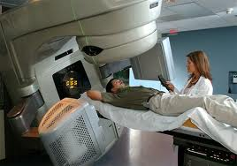

6
Internal Radiotherapy
There are two types of internal radiotherapy:

Brachytherapy gives a high dose of radiotherapy directly to the tumor but only a low dose to normal tissue. It is mainly used to treat cancers in the prostate gland, cervix and womb but it may also be used to treat some other cancers, such as heart and neck cancers. Also, brachytherapy involves putting radioactive seeds or rods inside the tumor. This will take the form of a drink or capsule or as an injection into a vein. Moreover, there are 2 types of brachytherapy, depending on the dosage:
- Low-dose-rate(LDR) brachytherapy
- High-dose-rate(HDR) brachytherapy

Radioisotope therapy uses radioactive substances known as radioisotopes or radionuclides. Radioisotopes are given by mouth as a drink or capsules, or injected into a vein (intravenous injection). Cancer cells absorb the radioisotope more than the normal cells do and receive a higher dose of radioactivity. This causes the cancer cells to die.

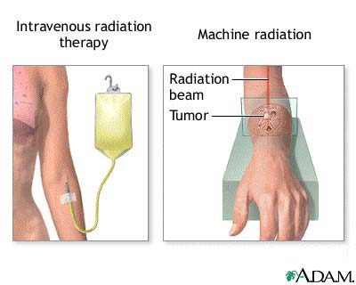

7
Side Effects of Radiotherapy
Radiotherapy affects people in different ways. Side effects occur because radiotherapy temporarily damages some healthy cells as well as destroying cancerous ones. The side effects depend on the type of treatment, the part of the body being treated, the dose of radiotherapy and how quickly healthy cells are able to repair the damage.
Possible side-effects include:
- Fatigue (tiredness)
- Dry, red or itchy skin
- Swelling
- Loss of appetite
- Nausea (feeling sick)
- Digestive problems
- Dry or sore mouth
- Cough or shortness of breath
- Hair-loss
- Changes in blood

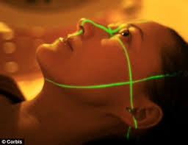

Conclusion
Radiotherapy is generally a vital aspect of both curative and palliative cancer treatment. Increasingly, evidence indicates that radiotherapy recruits biological effectors outside the treatment field and has systemic effects. Family physicians should consider radiotherapy for symptom relief for patients receiving palliative care.
Although exposure to high levels or radiation can be very harmful, the X-rays used for medical purposes are safe because the dose of radiation is very small.

8
Literature

Internet :Macmilllan Cancer Support
http://www.macmillan.org.uk/Cancerinformation/Cancertreatment/Treatmenttypes/Radiotherapy/Radiotherapy.aspx

Internet: Cancer Counsil Australia
http://www.cancer.org.au/about-cancer/treatment/radiotherapy.html#

Internet: NCBI
http://www.ncbi.nlm.nih.gov/pmc/articles/PMC1479480/

Internet: The Lancet Oncology
http://www.thelancet.com/journals/lanonc/article/PIIS1470-2045(09)70082-8/abstract

Internet: National Cancer Institute
http://www.cancer.gov/dictionary?cdrid=44295

Internet: IAEA
http://www.iaea.org/Publications/Booklets/RadPeopleEnv/medical.html

Internet: Cancer Research UK
http://www.cancerresearchuk.org/cancer-info/cancerandresearch/all-about-cancer/what-is-cancer/treating-cancer/history-of-radiotherapy/

Internet: BUPA
http://www.bupa.co.uk/individuals/health-information/directory/r/radiotherapy

Internet: Irish Cancer Society
http://www.cancer.ie/cancer-information/treatments/radiotherapy

9

